Build an EKS‑Like Kubernetes Platform Using K3s on AWS (Free Tier)
Private EC2 Nodes + Public ALB + Secure Access (No SSH)

1. Introduction
Running a managed Amazon EKS cluster is not free‑tier eligible, but many real‑world architectures can still be learned and implemented using K3s on EC2.
In this blog, we build an EKS‑like architecture using: - K3s (lightweight Kubernetes) - Private EC2 instances - Public Application Load Balancer (ALB) - Ingress / NodePort exposure - Session Manager instead of SSH
This mirrors how production EKS clusters are designed.

2. Final Architecture
Internet
|
v
Public ALB (80 / 443)
|
Target Group (NodePort / Ingress)
|
Private Subnets
|
K3s EC2 Nodes (No Public IP)
|
NGINX Pods
|
NAT Gateway (Outbound Only)

Key Design Principles
- No public IPs on EC2
- No SSH access required
- Only ALB is internet‑facing
- Kubernetes exposed via ALB

3. AWS Free Tier Services Used
Service | Purpose
VPC | Network isolation
EC2 (t3.micro) | K3s nodes
ALB | Public ingress
NAT Gateway | Outbound internet
CloudFormation | Infrastructure as Code
SSM Session Manager | Secure access

4. Stack 1 – Network + ALB (CloudFormation)
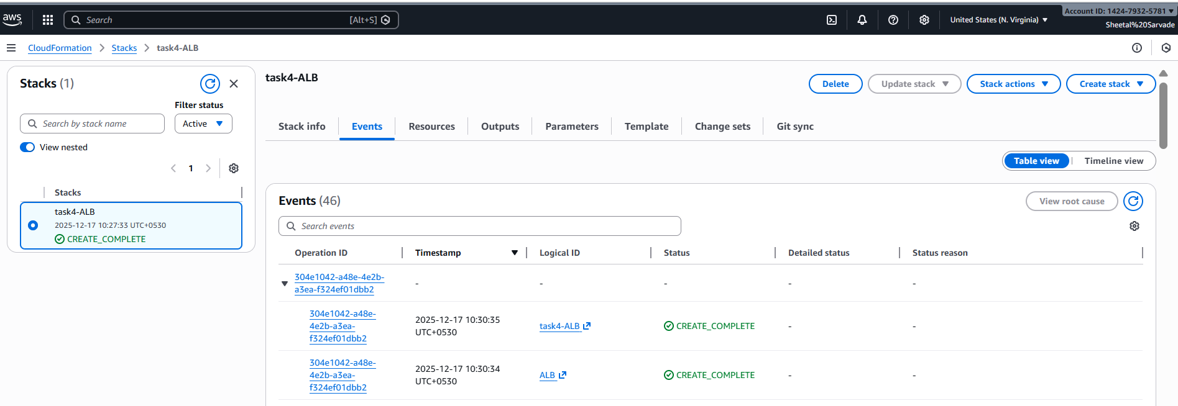
Network and ALB stack successfully created using CloudFormation.
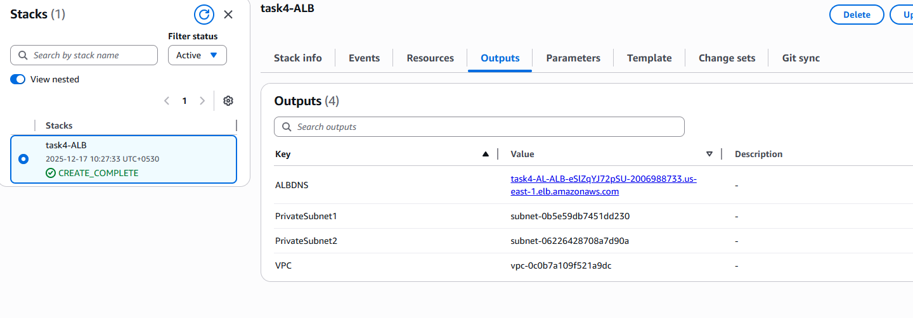
This stack creates: - VPC - Public & private subnets (multi‑AZ) - Internet Gateway - Public ALB - Target Group
This template is fully executable and can be deployed directly from the AWS console.
AWSTemplateFormatVersion: '2010-09-09'
Description: VPC with Public ALB and Private Subnets for K3s
Parameters:
VpcCIDR:
Type: String
Default: 10.0.0.0/16
Resources:
VPC:
Type: AWS::EC2::VPC
Properties:
CidrBlock: !Ref VpcCIDR
EnableDnsSupport: true
EnableDnsHostnames: true
IGW:
Type: AWS::EC2::InternetGateway
IGWAttach:
Type: AWS::EC2::VPCGatewayAttachment
Properties:
VpcId: !Ref VPC
InternetGatewayId: !Ref IGW
PublicSubnet1:
Type: AWS::EC2::Subnet
Properties:
VpcId: !Ref VPC
CidrBlock: 10.0.1.0/24
AvailabilityZone: !Select [0, !GetAZs '']
MapPublicIpOnLaunch: true
PublicSubnet2:
Type: AWS::EC2::Subnet
Properties:
VpcId: !Ref VPC
CidrBlock: 10.0.2.0/24
AvailabilityZone: !Select [1, !GetAZs '']
MapPublicIpOnLaunch: true
PrivateSubnet1:
Type: AWS::EC2::Subnet
Properties:
VpcId: !Ref VPC
CidrBlock: 10.0.11.0/24
AvailabilityZone: !Select [0, !GetAZs '']
MapPublicIpOnLaunch: false
PrivateSubnet2:
Type: AWS::EC2::Subnet
Properties:
VpcId: !Ref VPC
CidrBlock: 10.0.12.0/24
AvailabilityZone: !Select [1, !GetAZs '']
MapPublicIpOnLaunch: false
ALB:
Type: AWS::ElasticLoadBalancingV2::LoadBalancer
Properties:
Scheme: internet-facing
Subnets:
- !Ref PublicSubnet1
- !Ref PublicSubnet2

5. Stack 2 – Private EC2 Running K3s
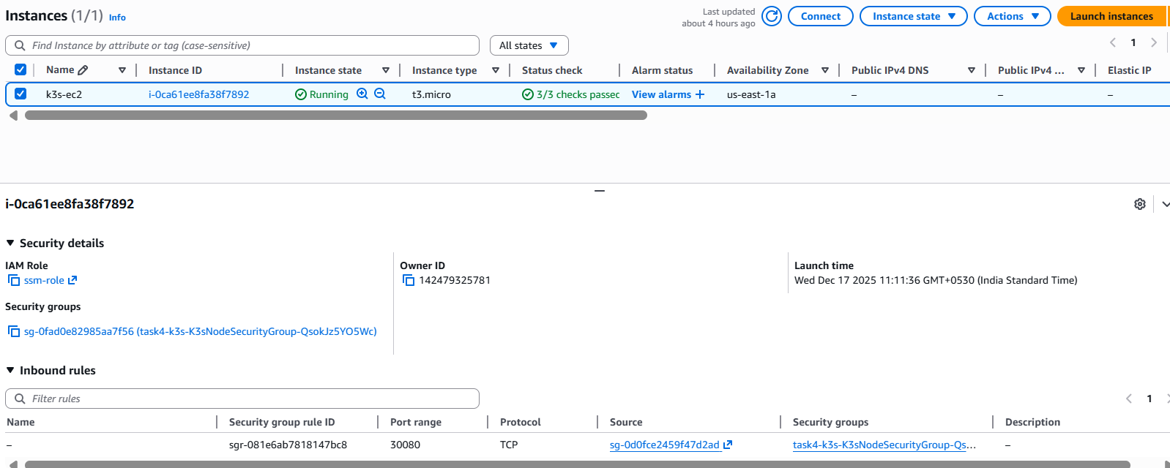K3s EC2 instance running in a private subnet with no public IPv4 address.

6. Secure Access Using Session Manager (No SSH)
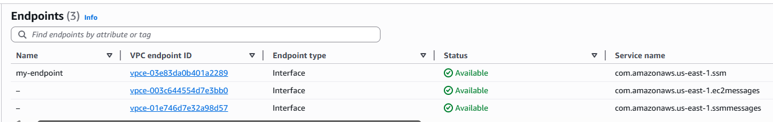
VPC Interface Endpoints (SSM, EC2Messages, SSMMessages) > VPC interface endpoints required for Session Manager connectivity without internet or SSH.
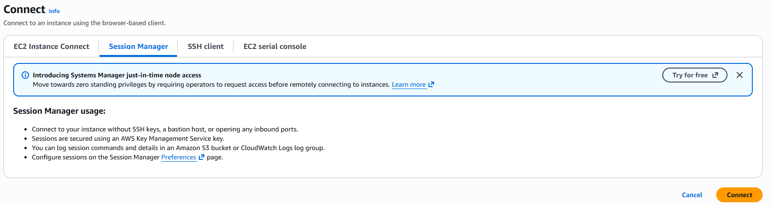
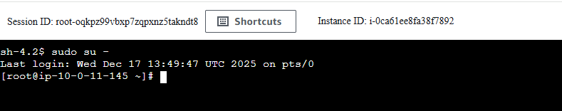
Session Manager Connected Terminal > Secure shell access to private EC2 using AWS Session Manager.

Why no SSH?
- No port 22 exposed
- No key management
- Fully audited access

Required VPC Endpoints
Endpoint | Purpose
ssm | Instance registration
ec2messages | Command delivery
ssmmessages | Interactive shell

How Session Manager Works
- EC2 boots with SSM Agent
- EC2 connects outbound on port 443
- AWS Console initiates session
- Encrypted WebSocket tunnel is created
- You get a shell — no inbound access required

7. Single Bootstrap Script (Everything Automated)
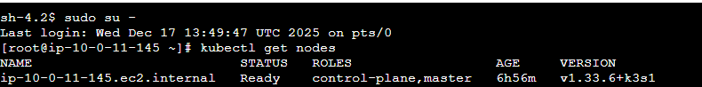kubectl get nodes > K3s node successfully registered and in Ready state.
This script: - Installs K3s - Deploys NGINX - Exposes via NodePort 30080 - Optionally applies Ingress
#!/bin/bash
set -e
curl -sfL https://get.k3s.io | INSTALL_K3S_SKIP_SELINUX_RPM=true sh -
sleep 30
k3s kubectl apply -f - <<EOF
apiVersion: apps/v1
kind: Deployment
metadata:
name: nginx
spec:
replicas: 2
selector:
matchLabels:
app: nginx
template:
metadata:
labels:
app: nginx
spec:
containers:
- name: nginx
image: nginx
ports:
- containerPort: 80
EOF
k3s kubectl apply -f - <<EOF
apiVersion: v1
kind: Service
metadata:
name: nginx-nodeport
spec:
type: NodePort
selector:
app: nginx
ports:
- port: 80
targetPort: 80
nodePort: 30080
EOF

8. Register EC2 to ALB Target Group
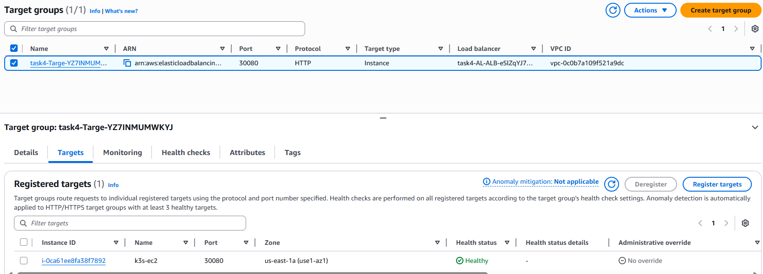ALB target group showing healthy EC2 instance on NodePort 30080.
- Target type: Instance
- Port: 30080
- Health check path: /
Once healthy, traffic flows:
ALB → EC2:30080 → K3s → NGINX Pod

9. Final Validation
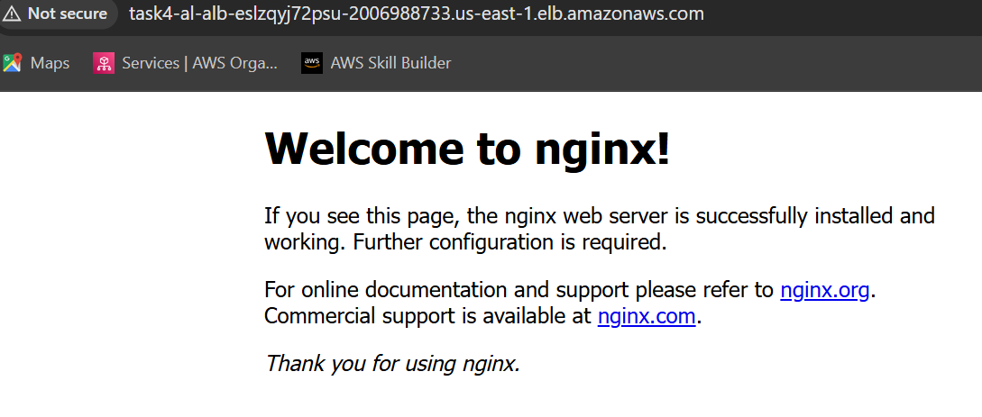
NGINX application successfully accessed through public ALB DNS.
curl http://<ALB-DNS-NAME>
You should see the NGINX welcome page.

10. Conclusion
This setup demonstrates: - EKS-like architecture without EKS cost - Private Kubernetes nodes - Secure, production-grade access - Real-world ALB + Kubernetes integration

Questions & Answers (K3s + ALB + Private EC2)

Q1. Why to use K3s instead of EKS?
Answer: Amazon EKS control plane is not free-tier eligible. K3s is a lightweight, CNCF-certified Kubernetes distribution that allows us to implement the same architectural patterns—private nodes, public ALB, and ingress—at zero control-plane cost.

Q2. Why are the EC2 instances private?
Answer: Private EC2 instances improve security by preventing direct internet access. All inbound traffic is routed through the ALB, and administrative access is handled using AWS Session Manager instead of SSH.

Q3. How does traffic flow from the internet to the Kubernetes pods?
Answer: Traffic flows from the internet to the public ALB, then to the EC2 instances in private subnets via the ALB target group. From there, Kubernetes services route the traffic to the appropriate pods.

Q4. What is NodePort and why was it used?
Answer: NodePort exposes a Kubernetes service on a fixed port on each node. It was used here to allow the ALB to forward traffic to the K3s cluster. In production, NodePort is typically used only to expose an ingress controller.

Q5. What is Ingress and how is it different from NodePort?
Answer: Ingress provides Layer-7 HTTP routing, path-based routing, and TLS termination. NodePort works at Layer-4 and exposes individual ports. Ingress is preferred for production workloads.

Q6. Why is ALB used instead of exposing EC2 directly?
Answer: ALB provides a single public entry point, health checks, high availability across AZs, and integration with AWS security features. It prevents direct exposure of EC2 instances.

Q7. How do you access a private EC2 instance without SSH?
Answer: Using AWS Systems Manager Session Manager. The EC2 instance connects outbound to AWS SSM endpoints over HTTPS, allowing secure, audited shell access without opening port 22.

Q8. What VPC endpoints are required for Session Manager?
Answer: Three interface endpoints are required: -
- com.amazonaws.<region>.ssm - for instance registration
- com.amazonaws.<region>.ec2messages for command delivery
- com.amazonaws.<region>.ssmmessages for interactive sessions

Q9. What happens if port 22 is removed from the security group?
Answer: SSH access is blocked, but the application continues to work normally. Session Manager access is unaffected, making this a recommended security practice.

Q10. How is outbound internet access handled for private EC2?
Answer: Outbound access is handled via a NAT Gateway, allowing the instance to download packages and container images without exposing it to inbound internet traffic.

Q11. Is this architecture production-ready?
Answer: Yes, the architecture mirrors production EKS designs. With enhancements like TLS, autoscaling, and ingress-only exposure, it can be safely used in real environments.

Q12. What are the main security benefits of this design?
Answer: - No public IPs on EC2 - No SSH access - ALB-only inbound traffic - IAM-based access control - Full audit logging via CloudTrail

Public Documentation References
The following official public sources were consulted to ensure technical accuracy:
- AWS Documentation – Application Load Balancer https://docs.aws.amazon.com/elasticloadbalancing/latest/application/introduction.html
- AWS Documentation – Systems Manager Session Manager https://docs.aws.amazon.com/systems-manager/latest/userguide/session-manager.html
- AWS Documentation – VPC Interface Endpoints https://docs.aws.amazon.com/vpc/latest/privatelink/what-is-privatelink.html
- K3s Official Documentation https://docs.k3s.io/
- Kubernetes Official Documentation – Services & Ingress https://kubernetes.io/docs/concepts/services-networking/

